Marriage of convenience between farmer organizations and milk industry, for a more resilient local milk value chain in Niamey

O. Renard, G. Ouseini

Abstract

Between 90 and 95% of milk consumption in Niamey is produced with imported powder milk. It allows urban population to access cheap and safe milk products, but local milk is preferred by most of the population. The development of local milk value chain is hindered by high production costs and scattered production. Competing with cheap powder imports is also more difficult with UEMOA Common External Tariff on milk at 5% only, to favour poor urban consumers. A project developed in partnership with IRAM and national and regional organisations, Nariindu Project, is considering that trying to develop mini dairies to promote local milk, as it is the case in many West African countries, is not financially viable. It is proposed alternatively to facilitate linkages between farmers and milk industries interested in developing local milk products. To do so, a minimum of 3000 litres/day have to be collected, which is a challenge but also a strong impetus for local value chain, offering regular incomes for farmers. To reach this objective, collecting platforms are not only collecting milk, but also providing advices and inputs to farmers, animal feed being a strategic one. Collecting platforms are also key institutional tools: owned by farmer organisations, they are linking farmers, milk collectors, industry and local authorities, for sound value chain and territorial development.

Keywords – Local milk value chain, milk industry, Niger, collecting platforms, farmer services

Introduction
The impact of recently signed trade agreements between West Africa and the European Union is considered by experts as potentially dangerous for local productions (CONCORD policy paper, 2013). It has been asked without success by civil society to protect local production, and particularly milk value chains, but the external tariff for this production has been fixed at 5% only, compared to 30% asked by African milk producers. If such low rate is insuring urban consumers’ access to cheap imported milk powder, it is also seriously endangering local milk value chains, sources of income for hundreds of thousands of families, mostly nomad or semi-nomad. Literature on local milk value chains in West Africa (Corniaux, C., 2014) is focusing mainly on the development of mini dairies, and how to maximise added value for producers. But successful and significant examples are very rare, most of mini-dairies processing very small quantities of milk, for a limited number of farmers. Other mini-dairies are forced to use powder milk to be financially viable, even if they were initially created to collect and sale local milk (and often financially supported by international donors). Their business model is thus similar to milk industries, the latter working mostly with milk powder, but incorporating also local milk to improve quality (fat content).
The aim of the project is to propose new efficient mechanisms allowing smallholder farmers to be sustainably connected to milk industry, for stable, negotiated and regular incomes from local milk.
The hypothesis of the project is that, working directly in close collaboration with milk industry to sale local milk is more efficient in terms of impact on value chain development and income generation than developing alternative, nascent and fragile value chains, targeting niche markets. Another hypothesis is that local industry in West Africa can develop innovative partnerships with farmer organisations, not only to collect local milk, but also to offer local products to urban consumers.

Method
To reach this aim, the Nariindu project has supported the development of two local milk collecting platforms (on 2 sites, distant of 50 kilometres from Niamey (Kollo and Hamdallaye localities)). Nariindu project is managed during 3 years (2012 to 2015) by IRAM Development NGO, in partnership with VSF-Belgique, Karkara local NGO, and two farmer associations (AREN, in Niger, and RBM, in West Africa).
To show the economic and social viability of such innovation, the project has monitored both quantitative data on platforms’ turn over and impact at farmers’ level, and qualitative information on various indicators, to assess the social acceptability of platforms and their services.
The quantity of milk collected has been regularly measured by both platforms and the milk company, on a daily basis. Financial monitoring has been conducted by the project on bi-annual basis, to measure progress and make recommendations.
The project monitoring and evaluation plan has measured some key indicators: daily incomes and expenses at farmers’ level, qualitative information on changes in practices, gender issues, animal health status, and level of satisfaction regarding the services of the platforms. A baseline survey has been conducted in 2013, an end line survey in 2015. This survey was primarily designed to ensure satisfactory project implementation and monitor few key indicators, not for research purpose. Data collected and information should therefore be considered as indicative. More in-depth research is necessary to draw more precise and robust lessons.

Results
Results can be described around 3 dimensions: economic, social and institutional. Economic results are described briefly on figure 1: daily milk collection can reach approximately 600 litres per day in pic season in 2014, approximately 1000 litres in 2015, thanks to better functioning of the two centres. This covers two thirds of the supply in fresh milk for the partnering milk company. The main remaining problem is the strong decrease in milk collecting before rainy season, period of high milk consumption, but also a period during which cow herds are moving south to access grassland.
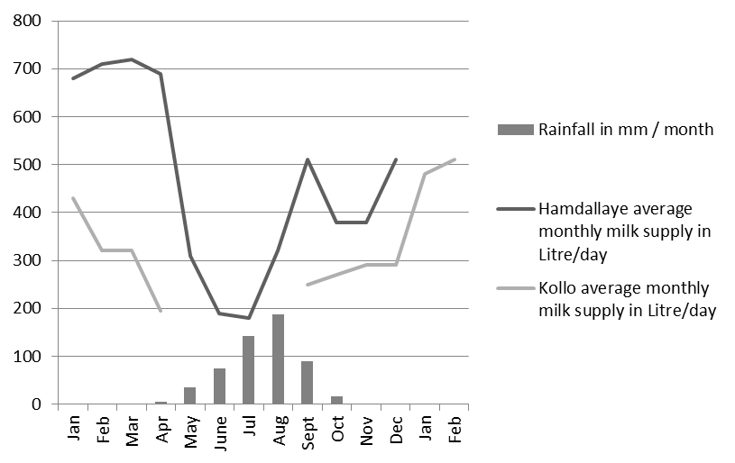
Figure 1: seasonality of milk collection (2014)
Approximately 1000 families are supplying milk, mostly poor families, and richest owners being traditionally not selling milk, offering it to shepherds. One cow is producing 2 to 4 litres per day, one to two litres per family per day being sold. Data is showing (Figure 2) that the centres have been chosen by most producers to sale milk after two years. This is due firstly to the service provided to farmers: daily milk collection and access to animal feed at negotiated price.

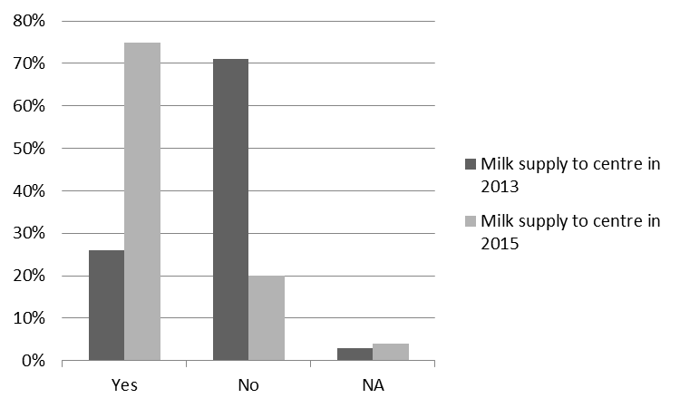 Figure 2: percentage of milk going to collecting platforms in selected villages (2013 and 2015)
Price negotiation is also one factor explaining the success of the platforms: the price increased from 300 litres to 400 litres at platforms’ gate. Lastly, the project end line study has shown that the animal health status significantly improved during the project, not only due to veterinary medicine, but also to access to animal feed at critical periods. For the milk company, having access to milk in quantity and quality has allowed it to launch a new product (successful yoghourt with guaranteed 100% local milk), the added value being shared upstream with farmers.

Social impact at farmers’ level is important. The impact on women has been particularly monitored, and figure 3 is showing that the status of women has changed positively with the change in milk practices. Selling on daily basis milk directly to milk collectors instead of having to go to local market two times per week is saving a lot of time for other activities. Besides, families are continuing to produce and sale traditional cheese for local consumption and occasional sales, at village level.
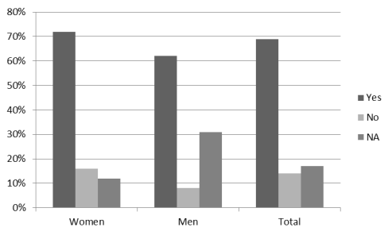
Figure 3: positive perception on status of women, by women and men (2015)
Institutional innovations are major ones, in terms of sustainability of the local value chain: the milk collecting platforms are insuring quality control, supply of animal feed and other inputs; but the fact that it is managed by farmer organisations instead of privately owned is facilitating dialog between farmers, organised collectors and the milk company. The farmer organisations are also legitimate to dialog with local authorities regarding legal enforcement of key state services: vaccination campaigns, access to animal feed with more transparent mechanisms, ensuring more enabling environment for all value chain actors.
One weakness of this innovation is the limited management capacity of the farmer organisations: they need significant initial support by projects, and have to be frequently monitored. Regarding consumer demand for milk, a survey has shown that local milk is preferred to powder milk, but safety is also a concern limiting confidence in local products. Moreover, labelling and communication on products’ content and origin is not yet enough reliable to promote safe local milk. The legal framework and enforcement has its role to play to promote safe local milk consumption.

Acknowledgement
IRAM would like to thank the Nariindu project’s partners: Karkara, VSF-Belgique, AREN, RBM for their fruitful collaboration, Afd and CFSI for their financial and technical support.

References
Mamane, O.B., Ouseini, G. (2015), Rapport situation fin de projet Nariindu, IRAM - Karkara
Rigourd, C., Ouseini, G. (2015), Mission d’appui au projet Nariindu - Bilan de l’année 2014 des deux centres de collecte et perspectives de viabilité, IRAM
Corniaux, C., Duteurtre, G., Broutin, C. (2014). Filières laitières et développement de l’élevage en Afrique de l’ouest, ed. Karthala.

Renard 0. is from IRAM Development NGO, Paris, France (o.renard@iram-fr.org). Ouseini G. is from Karkara NGO, Niamey, Niger (ouseini2000@yahoo.fr).

